Lab Performance 1: FCFS

ID – 202003112

Name – Pranesh Chowdhury

**FCFS Algorithm implemented by C Programming:**

#include<stdio.h>

int main()

{

int n;

int pt[]= {1,2,3};

printf(" Input Total Process: ");

scanf("%d", &n);

int bt[n];

printf(" Enter The Burst time for process: \n");

for (int i=0; i<n; i++)

{

printf(" P%d : ", i+1);

scanf("%d", &bt[i]);

}

printf("\n Burst time :\n");

for(int i=0; i<n; i++)

{

printf("\t%d\n",bt[i]);

}

avg(n,pt,bt);

}

int avg(int n, int pt[],int bt[])

{

int wt[n];

int tt[n];

int total=0;

waiting(wt,bt, n);

turnaround(wt,bt,n);

for(int i=0; i<n; i++)

{

total =wt[i]+ total;

}

double avgwt=total/(double)n;

printf(" Average Waiting Time: %.3lf\n",avgwt);

}

void waiting(int wt[],int bt[], int n)

{

wt[0]=0;

printf(" Waiting Time :\n");

for(int i=1; i<n; i++)

{

wt[i]=bt[i-1]+ wt[i-1];

}

for(int i=0; i<n; i++)

{

printf("\t%d\n",wt[i]);

}

}

void turnaround(int wt[],int bt[],int n)

{

int tt[3];

int total =0;

printf(" Turn Around Time:\n");

for(int i=0; i<n; i++)

{

tt[i]=wt[i]+bt[i];

printf("\t%d\n",tt[i]);

}

for(int i=0; i<n; i++)

{

total=tt[i]+total;

}

double avgtt = total/(double)n;

printf(" The Average Turn around Time: %.3lf\n",avgtt);

}

**Screenshot of IDE (code):**

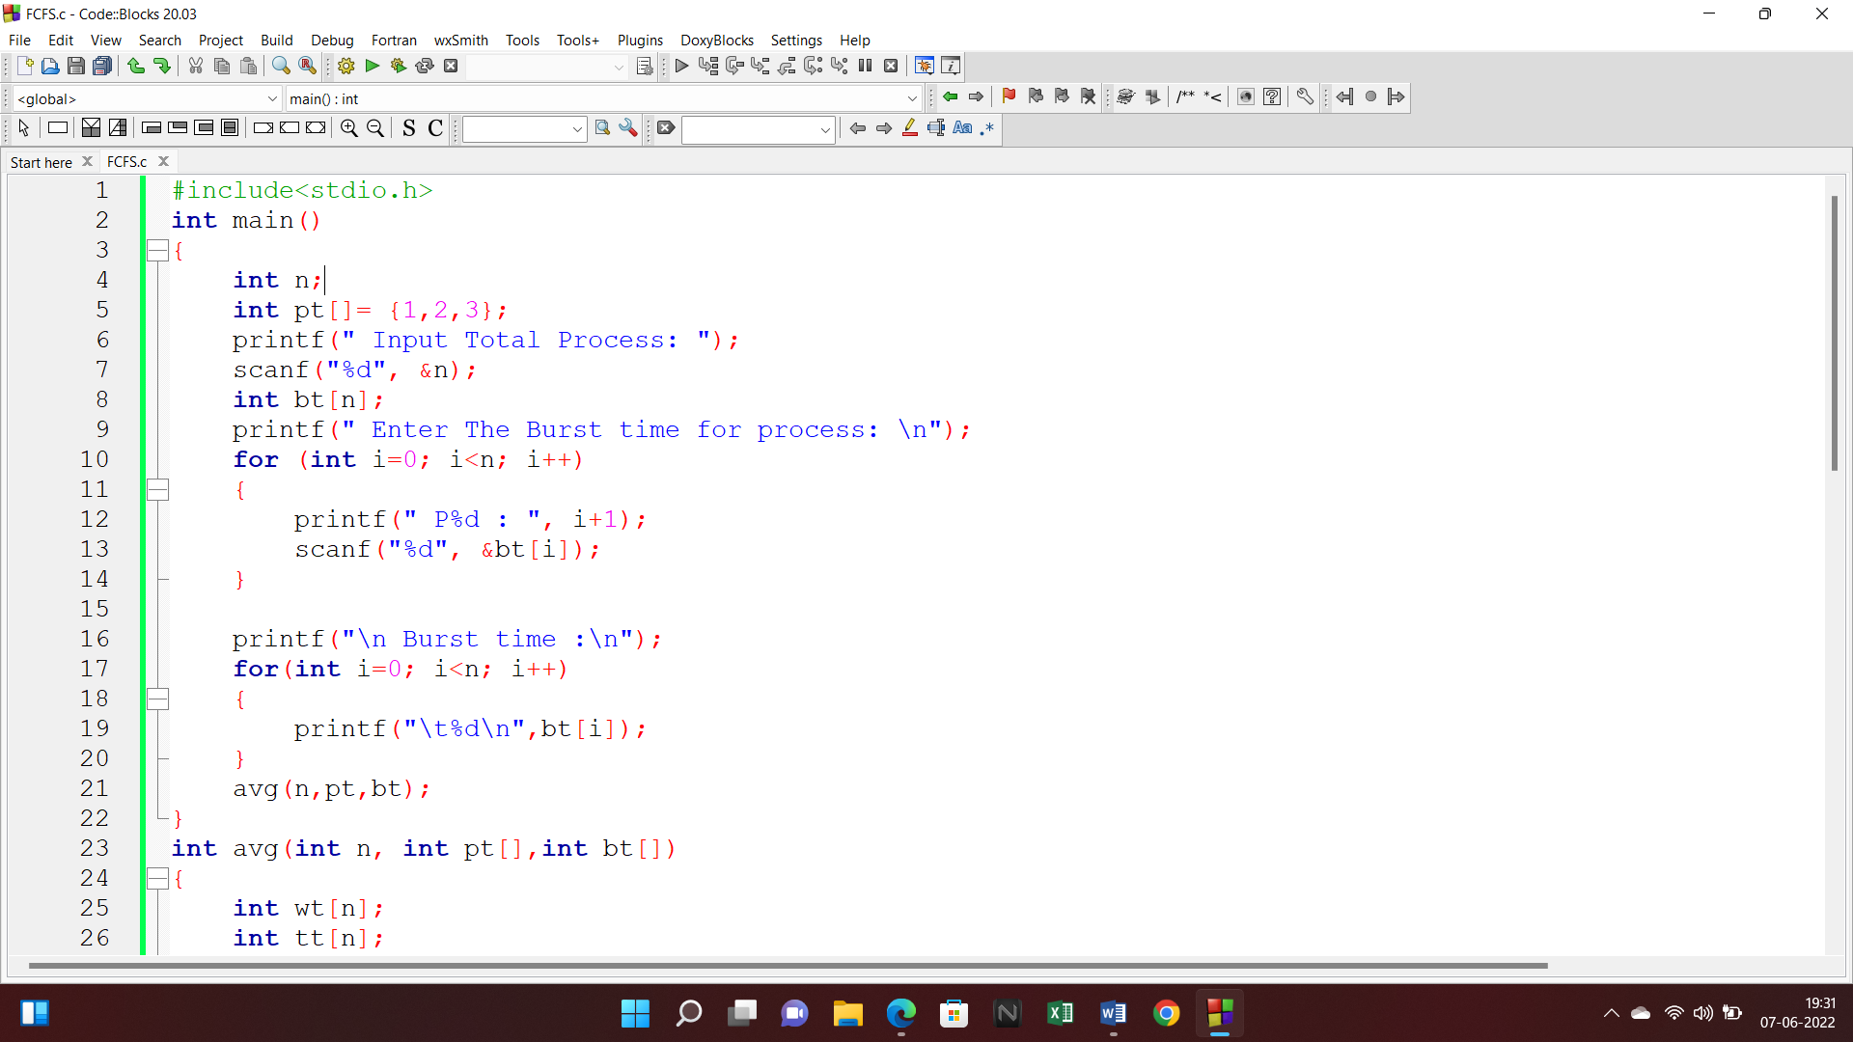

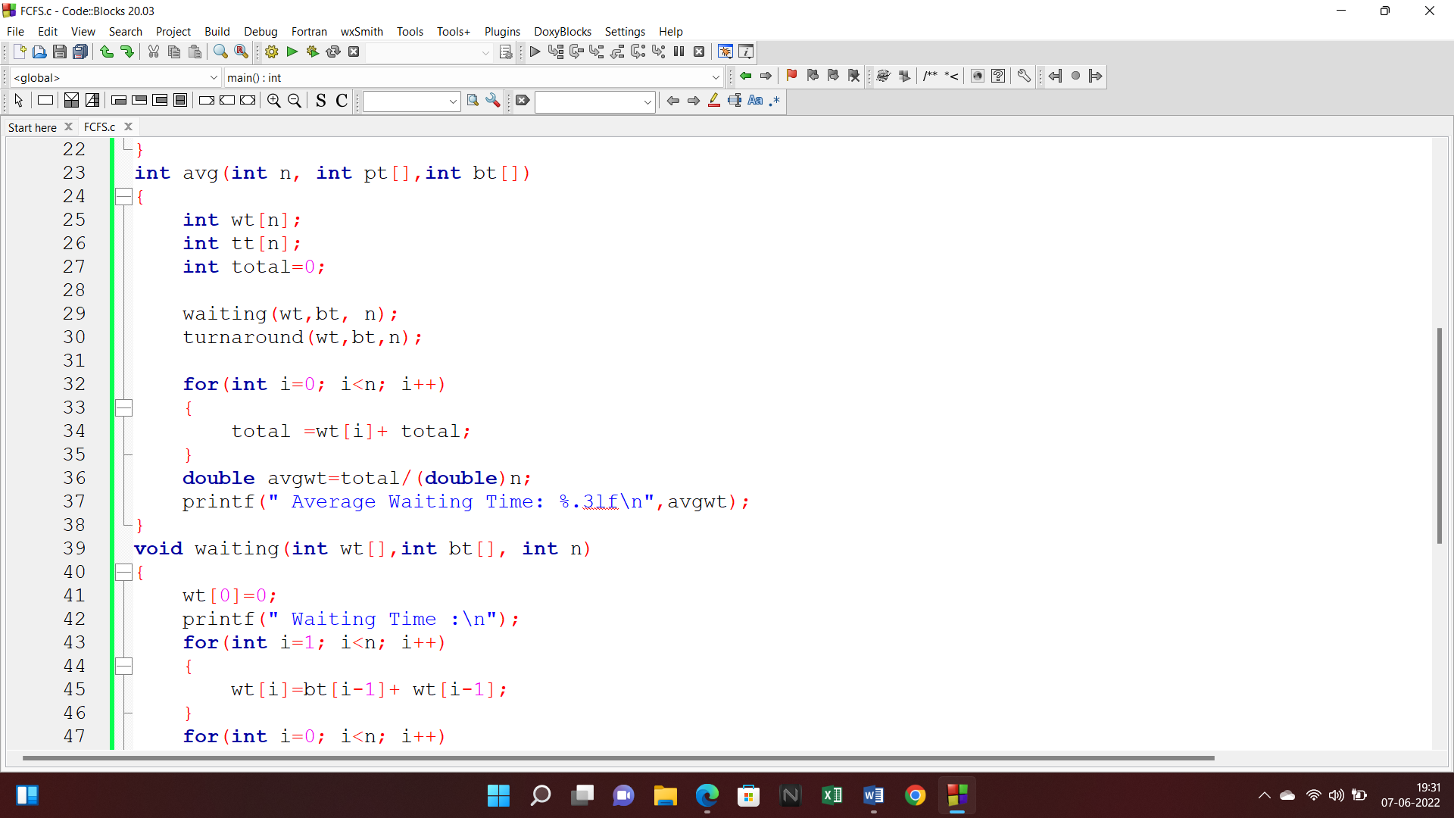

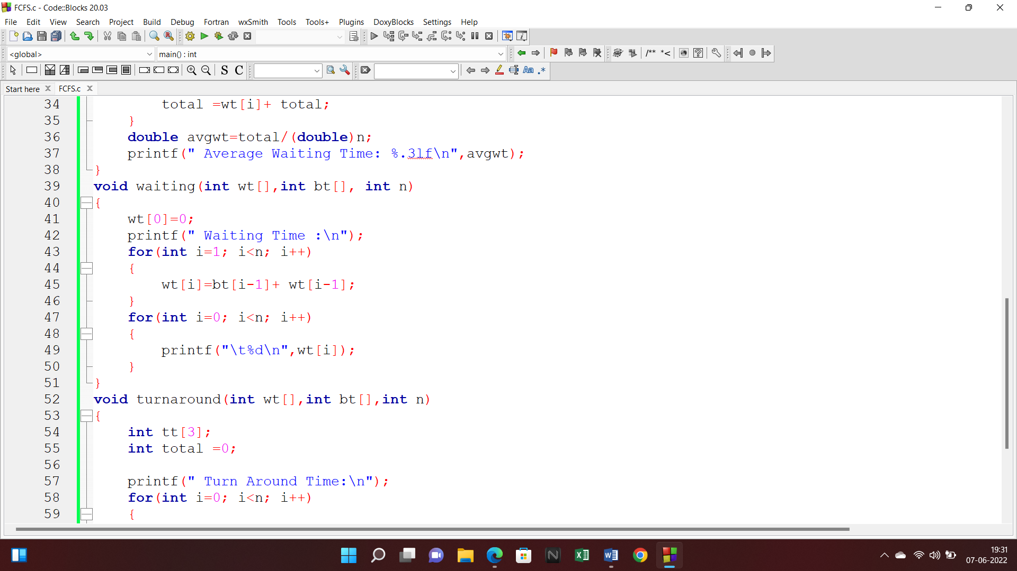

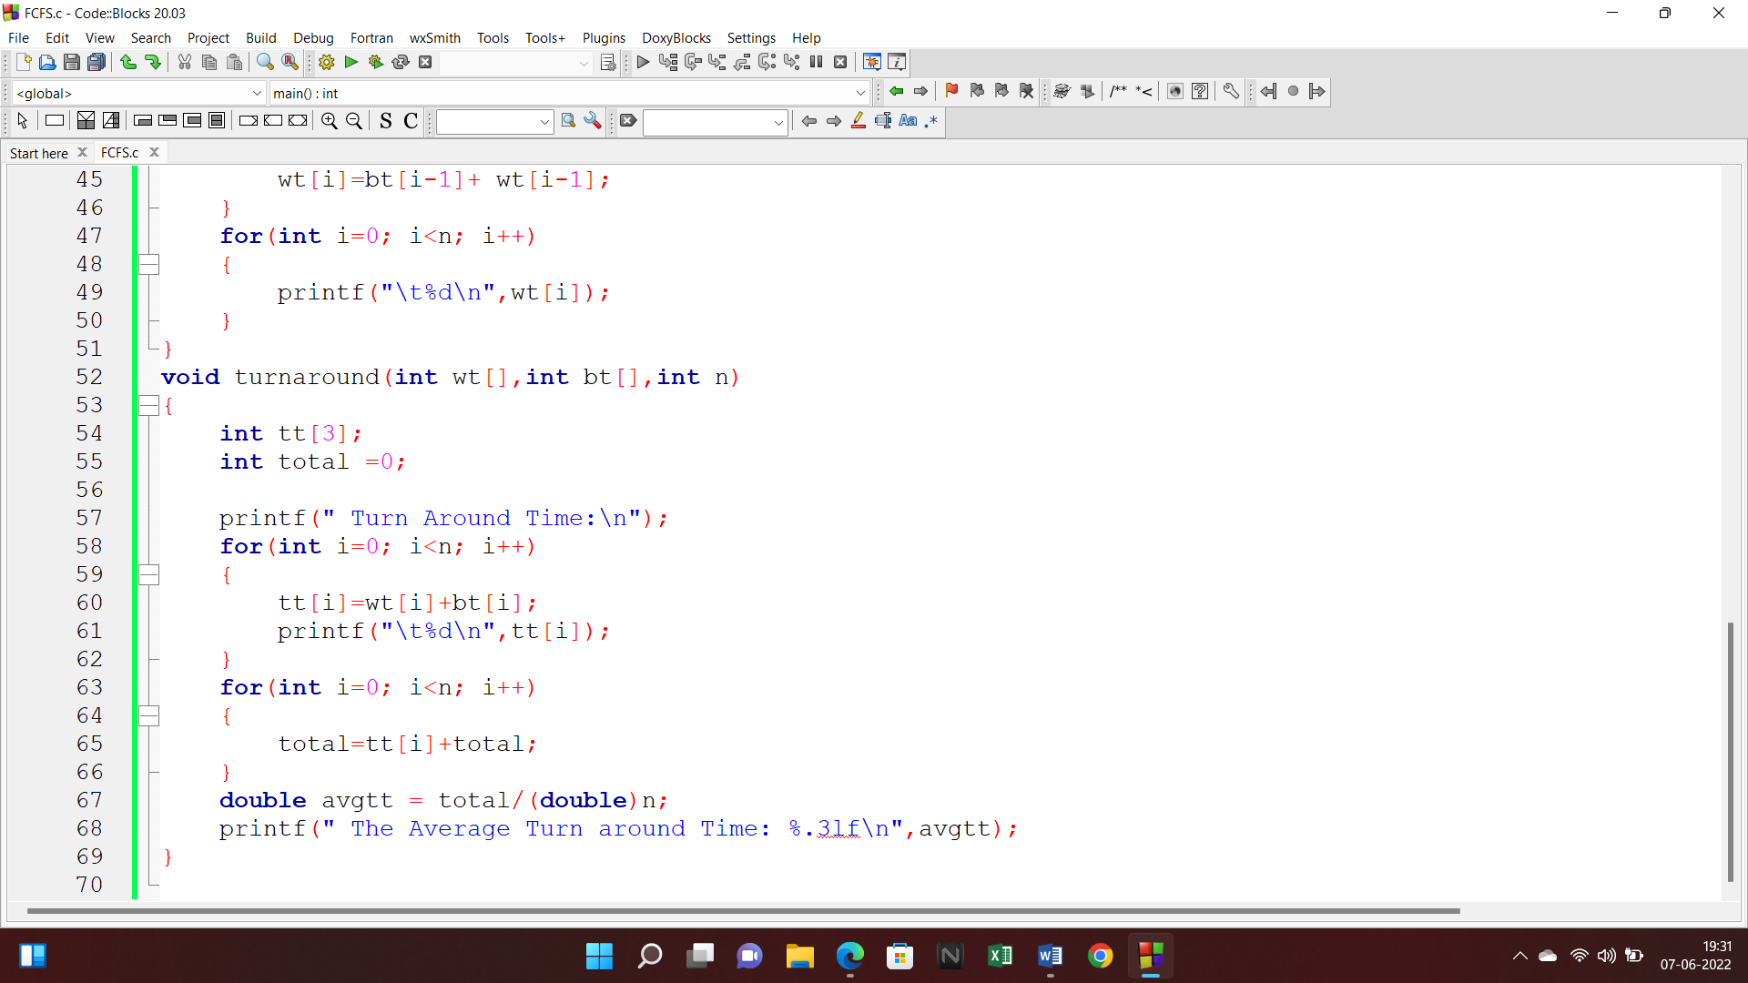

**Output:**

